Commodore CBM8296 Diagnostic: J4 Breakout Board Rev. 0  
Module Description

# Introduction

This J4 Breakout Board is part of the diagnostic clip set for the Commodore CBM8296. The original 324805-01 User Port Dongle incorporated a connector for the J4 memory expansion pin header. This breakout board has a 2x5 box connector, which attaches to the User Port Dongle (project number 209) of this diagnostic setup via a ribbon cable.

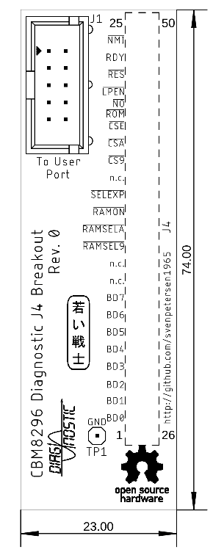

Figure 1: Dimensions of the J4 Breakout Board

TP1 is an optional test point, that could serve as a GND connection for measurements.

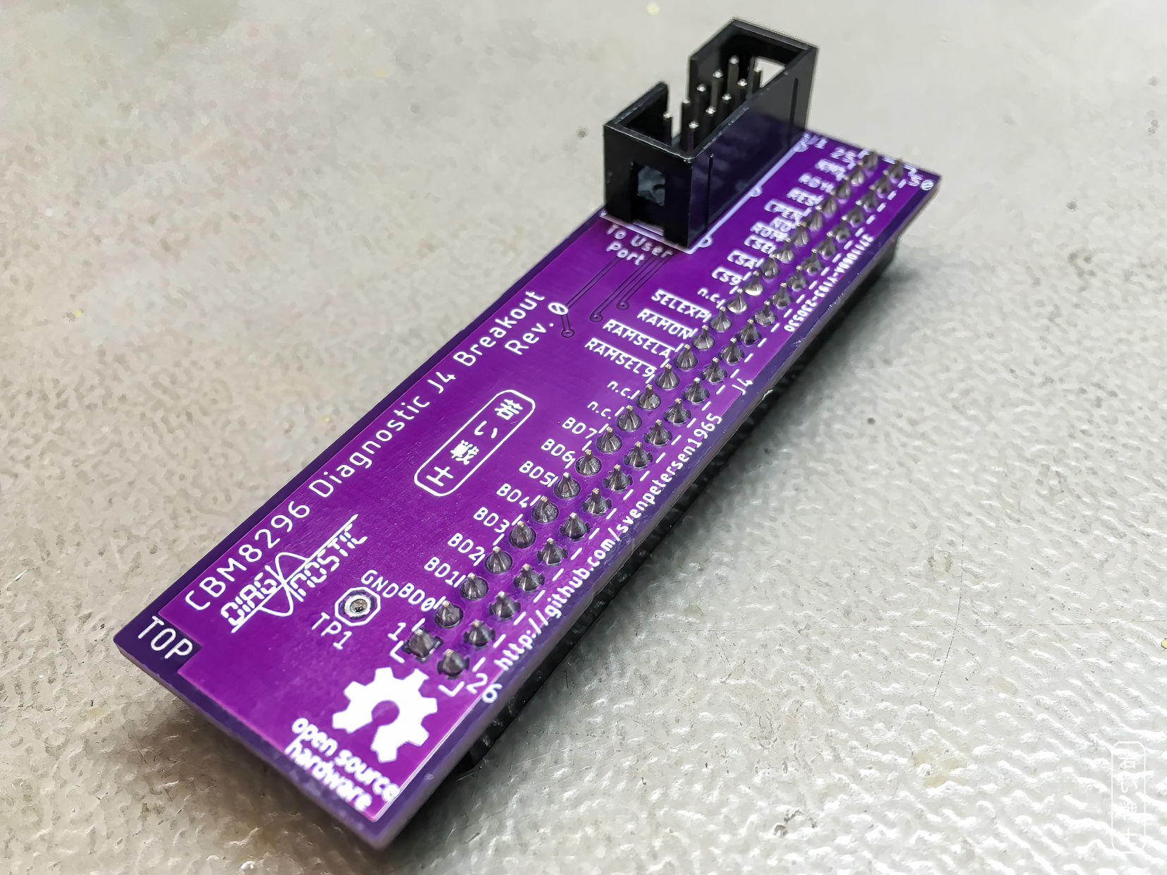

Figure 2: Top side of the J4 breakout boards

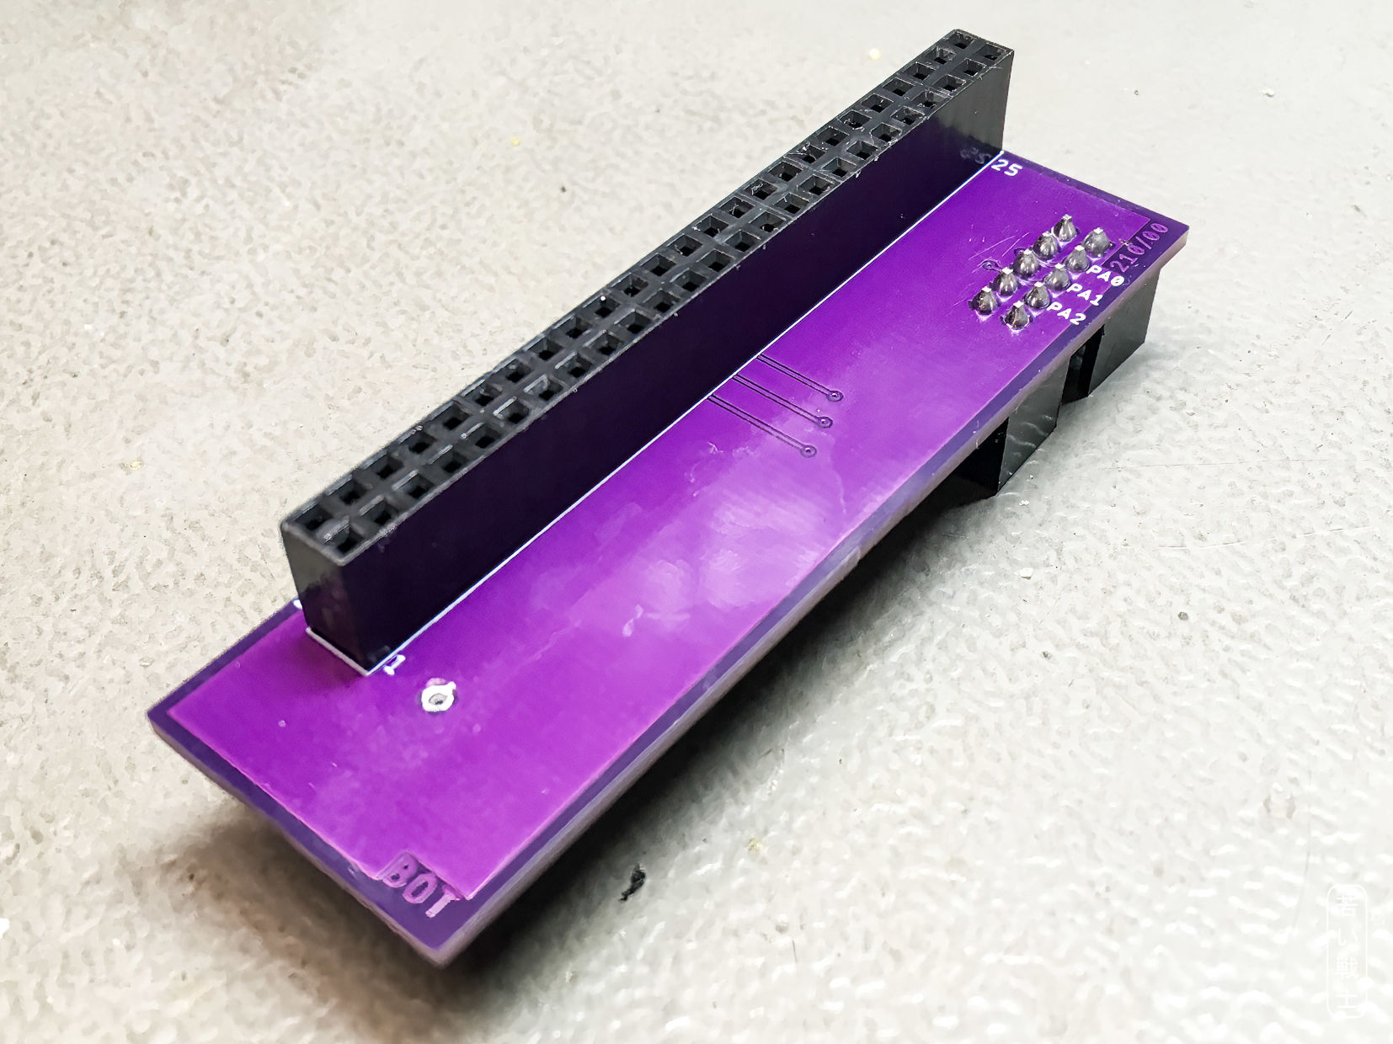

Figure : Bottom side of the J4 breakout board

# Connections

|  |  |
| --- | --- |
| Connection | Signals |
| B - M | CA1 - CB2 |
| C - J4.13 | PA0 - |
| D - J4.14 | PA1 - |
| E - J4.12 | PA2 - |

# Revision History

## Rev. 0

* Prototype, not yet tested.